\* All Figure titles are highlighted to make them easier to be found for modifying the sequence number.

Gap between Accessibility and Disability in Great Britain

Background

According to Department for Transport (2017), 9% of adults have difficulty on mobility. Disabled people over the age of 16 have 38% less trips than those with no disability. Among people over the age of 70, this ratio is 50%. The accessibility to disabled people of the railway public transport (% fully accessible vehicles) increased by 5 percentage points in 2016-2017, at 75%. As specified in the Equality Act 2010, ‘all station operators to take reasonable steps to ensure that they do not discriminate against disabled people’ (Department for Transport, 2015). Currently, the Department for Transport and Disabled Persons Transport Advisory Committee is working to maximize the accessibility of trains by 2020.

There are many facilities that can improve the accessibility of the station (Network Rail, 2019), such as:

1. lifts that are automatic and give an audible tone when the doors open and close

2. staircases and platform edges that have tactile warning surfaces

3. new ramps and footbridges with lowered handrails

4. open entrances and new ticket gates

5. accessible waiting rooms and toilets

As far as the status quo is concerned, there is still a gap in the complete accessibility of train transportation. Visualisation can better assist with the analysis. This visualisation aims to analyse whether the construction of the accessible facilities in train stations match the distribution of the disabled population. In this section, accessibility represents the percentage of accessible rail stations in all stations in the local authority. A special case is when the number of rail stations of the local authority is 0, the proportion is 0. Disability represents the disabled population density and proportion in local authority.

Method

There are six raw data files for the visualisation. These six data files include four table files (csv and xls) and two shapefiles:

1. Great Britain Local Authority Districts Boundaries shapefile (Office for National Statistics, 2017)

2. England and Wales Disability Data xls file shapefile (Office for National Statistics, 2012)

3. Scotland Disability Data csv file (Scotland’s Census, 2013)

4. Great Britain Rail Stations Location csv file (Doogal, 2019)

5. Great Britain Rail Station Accessibility Data csv file (Paulley, 2018)

6. UK Rail Lines shapefile (Diva-GIS, 2019)

The first five pieces of data have been processed and integrated before being used for the final html page visualisation:

1. England and Wales, and Scotland's disabled population data are cleaned up via Excel and ArcMap and integrated with the local authority's polygon layer.

2. Use ArcMap to calculate the area of each local authority polygon.

3. The table with the geographic information of the train station is converted into a point layer by the display latitude and longitude coordinates in ArcMap, and integrated with the station accessibility data.

4. Use ArcMap to calculate the number of all station points and accessible station points in each local authority polygon.

5. Use ArcMap to calculate the corresponding accessible station population, disabled population density and proportion.

6. The integrated shapefiles are uploaded to the Mapbox.

Visualisation

First, the green layer represents the proportion of accessible stations in each local authority. Different green shades correspond to different percentages. The darker the green area, the lower the percentage. When users use the mouse hover on different local authorities, in the information bar in the lower left corner, users can get the number of accessible stations and total stations, as well as the disabled population of this local authority.

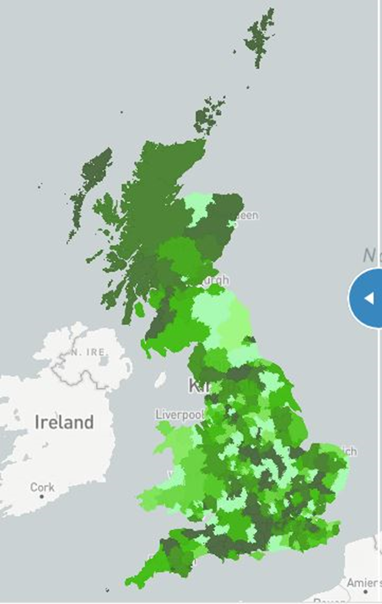 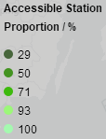

Figure 1: Accessible Station Proportion

Second, when users drag the blue slider, users can see more layers and compare them with accessibility. The blue and grey dot layers show the distribution of accessible and inaccessible stations. The grey line layer shows the rail lines. In the top right corner of the page, users can choose to show and hide them separately (Mapbox, 2019a). Similarly, when the mouse hover over different stations, users can also get information about the accessible facilities of this station. In addition, after dragging the screen, users can filter and find stations in the search box that appears on the left (Mapbox, 2019b).

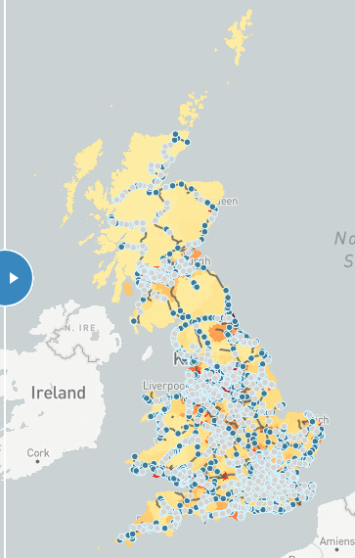

Figure 2: Rail Stations and Lines

Then, it's the core function of this page: comparing the status of accessibility and disability (Mapbox, 2019c). Users can choose to switch between density (disabled population / total population of local authority) and proportion (disabled population / total population of local authority) layer. Dark areas have a higher disabled population density and proportion. The zoom feature of several major cities is available at the top left.

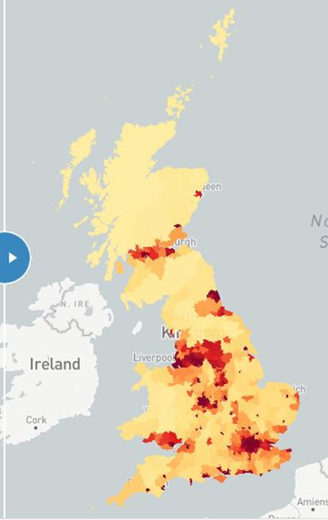 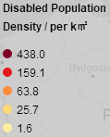

Figure 3: Disabled Population Density

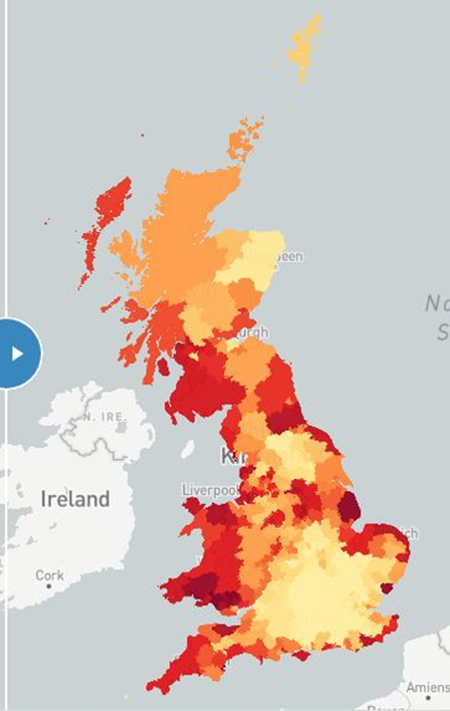 

Figure 4: Disabled Population Proportion

Results

By observing several maps in the visualisation, a few simple results can be obtained. Based on the choropleth map of the disabled population density, it is easy to find the major economic city has greater density. This may be due to the fact that the total population of these regions is even larger. Looking at the disabled population proportion, the local authorities with larger proportion are concentrated in the coastal areas. Perhaps because the coastal areas are more liveable. Take accessible station proportion as a comparison, it can quickly understand that the disabled population proportion is more in line with the accessible station proportion, which directly reflects the correlation with demand. The difference is that the disabled population density is less consistent with the accessible station proportion. In order to better understand the reasons, it need to do more specific analysis.

Here will choose two specific regions to explore. The first is Greater London. Its disabled population density is completely different from the proportion. There are more stations distributed in London's local authorities. Although the proportion of accessible stations is not large, the number of accessible stations is higher. Therefore, disabled people can find more alternative stations within a short distance.

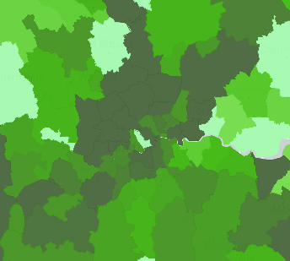

Figure 5: Accessible Station Proportion (London)

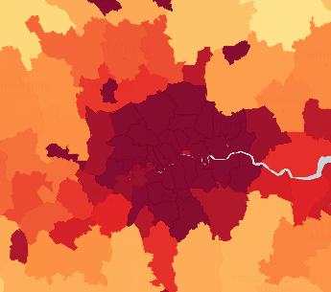

Figure 6: Disabled Population Density (London)

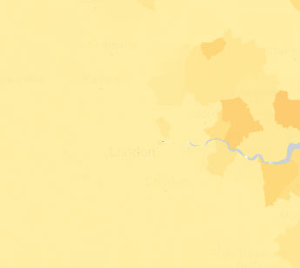

Figure 7: Disabled Population Proportion (London)

The second is Liverpool and Knowsley. Their disabled population density and proportion are both relatively high. These two adjacent and similarly-sized cities are a good verification of many of the results that have previously obtained. They are located in major economic and coastal areas. On the one hand, Liverpool has a higher disabled population density and a lower proportion than Knowsley. On the other hand, Liverpool has more than twice as many accessible stations as Knowsley, and with a lower accessible station proportion.

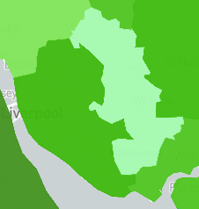



Figure 8: Accessible Station (Liverpool and Knowsley)

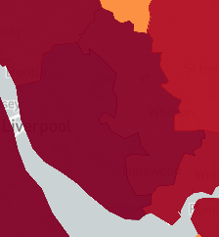

Figure 9: Disabled Population Density (Liverpool and Knowsley)

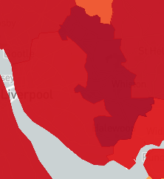

Figure 10: Disabled Population Proportion (Liverpool and Knowsley)

As a small conclusion, disabled population density and proportion have significant differences in different local authorities. Comparing them with accessibility proportion will get different results. Accessibility in Great Britain is somewhat compatible with the disability status. However, different improvements are still needed. In the local authority with a higher disabled population density, although the number and density of accessible stations are higher, the proportion is lower. In the local authority with a higher disabled population proportion, although the proportion of accessible stations is very high (close to 100%), due to distance factors, disabled people may need to overcome more difficulties to reach the stations. This is not a part of this visualisation, however, it is an area worthy of follow-up attention.

References

Department for Transport (2015) *Accessible rail transport*. [Online]. Available at: https://www.gov.uk/government/publications/accessible-rail-transport/accessible-rail-transport

Department for Transport (2017) *Transport Statistics Great Britain 2017*. London: Department for Transport.

Diva-GIS (2019) *Spatial Data Download - Country: United Kingdom - Subject: Railroads*. [Online]. Available at: http://www.diva-gis.org/gdata

Doogal (2019) *UK stations*. [Online]. Available at: https://www.doogal.co.uk/UkStations.php

Mapbox (2019a) *Show and hide layers*. [Online]. Available at: https://docs.mapbox.com/mapbox-gl-js/example/toggle-layers/

Mapbox (2019b) *Filter features within map view*. [Online]. Available at: https://docs.mapbox.com/mapbox-gl-js/example/filter-features-within-map-view/

Mapbox (2019c) *Swipe between maps*. [Online]. Available at: https://docs.mapbox.com/mapbox-gl-js/example/mapbox-gl-compare/

Network Rail (2019) *Access for All – improving accessibility at railway stations nationwide*. [Online]. Available at: https://www.networkrail.co.uk/communities/passengers/station-improvements/access-for-all/

Office for National Statistics (2017) *Local Authority Districts (December 2017) Super Generalised Clipped Boundaries in Great Britain*. [Online]. Available at: https://geoportal.statistics.gov.uk/datasets/local-authority-districts-december-2017-super-generalised-clipped-boundaries-in-great-britain

Office for National Statistics (2012) *2011 Census: QS303EW Long-term health problem or disability, local authorities in England and Wales*. [Online]. Available at: https://www.ons.gov.uk/peoplepopulationandcommunity/populationandmigration/populationestimates/datasets/2011censuskeystatisticsandquickstatisticsforwardsandoutputareasinenglandandwales

Paulley, D. (2018) *Rail station accessibility data*. [Online]. Available at: https://www.kingqueen.org.uk/rail-station-accessibility-data/

Scotland’s Census (2013) *Long-term activity-limiting health problem or disability by council area, Scotland, 2001 and 2011*. [Online]. Available at: https://www.scotlandscensus.gov.uk/bulletin-figures-and-tables